

**LA GRANDEE INTERNATIONAL COLLEGE**

**Simalchaur, Pokhara Nepal**

Case Study Report on

**“Amazon.com”**

**Submitted By:**

Sapna Baniya Mahima Sharma

19530129 19530113

BCA Seven (7th) BCA Seven (7th)

**Submitted To:**

**Er. Kiran K.C**

**Lecturer/Principal**

**LA GRANDEE International College**

**Date: 2023-01-30**

**Student’s Declaration**

**A Case Study on “Amazon.com”**

We, hereby, declare that this case study has been carried out as requirement for completion of the course E-Business of 7th semester of BCA program under the supervision of our Lecturer/Principal, Er. Kiran K.C. We further declare that we are the only author of this case study report and that no sources other than those listed in this report have been used in this study.

1. Name: Mahima Sharma Exam Roll No: 19530113 Signature:
2. Name: Sapna Baniya Exam Roll No: 19539129 Signature:

**APPROVAL CERTIFICATE**

This is to certify that Ms. Mahima Sharma and Ms. Sapna Baniya , 7th semester students of BCA program at LA GRANDEE International College with PU registration number 19530113 and 19530129 respectively have successfully completed the case study on “ Amazon.com” as per the requirement prescribed under the course E-business.

The study has been found satisfactory and is thus approved.

…………………………..

Er. Kiran K.C.

Lecturer/Principal

Date : 2023-01-30

# **ACKNOWLEDGEMENT**

We express our sincere regard to our case study supervisor Mr. Er. Kiran K.C., for his valuable time, guidance, encouragement, support, and cooperation throughout our project. We would like to thank BCA Department for allowing us to work on enhancing our technical skills while undergoing this project. This is a case study report on Flipkart which is carried out as an ingredient of assignment as specified by the faculty member for the degree of BCA, 6th semester. We are very thankful that you have provided us with an opportunity to show our talent and also to sharpen our knowledge.

With Regards,

Mahima Sharma (Roll No: 19530113)

Sapna Baniya (Roll No: 19530129)

Contents

ACKNOWLEDGEMENT IV

List of Figures VI

1.INTRODUCTION 1

1.1Team Members 1

1.2PURPOSE OF CASE STUDY 2

1.3 E-Business Site Name 2

1.4 Year of Establishment 2

1.5 Owner/Developer 2

1.6 Current Location of Operation/Office 3

1.7 BUSINESS MODELS 4

1.7.1Based on relationship transaction parties 4

1.7.2 Based on the relationship of transaction types 4

1.7.3 Based on revenue model 4

1.7.4Based on Distribution channel 5

1.8 ANNUAL TURNOVER 6

2.TARGET CUSTOMERS 9

3.BUSINESS OBJECTIVES 10

4.PRODUCTS AND SERVICES 11

5.FUNCTIONS AND OPERATIONS 12

5.1 Process of Buying Goods and services on Amazon : 12

5.2 Process of selling Goods and services: 12

a. Process before Register: 12

b. Process after Register: 12

6.COMPARISION WITH OTHER SIMILAR WEBSITES 13

6.1 ebay 13

6.2 AliExpress 13

6.3 Miniln TheBox 13

6.4Newegg 13

6.5Walmart 13

7. LEARNING FROM THE CASESTUDY 14

a. . Obsess over customers, not competitors 14

b. Take risks for market leadership 14

8.PAYMENT MODES: 14

Credit Cards 15

Amazon Store Cards 15

Gift Cards 15

9.Screenshots 16

10.References 19

# List of Figures

Figure 1 Net Sales Revenue of Amazon.com 6

Figure 2 Net Sales of Amazon.com in Leading countries 7

Figure 3 Home Page 16

Figure 4 Sign In Page 16

Figure 5 Category List 17

Figure 6 Amazon Gift cards 17

Figure 7 Amazon Services 18

# **1.INTRODUCTION**

Amazon.com, doing business as Amazon, is an American electronic commerce and cloud computing company based in Seattle, Washington that was founded by Jeff Bezos on July 5, 1994. But it went public in May, 1997. The tech giant is that the biggest Internet retailer within the globe as measured by revenue and capitalization, and second largest after Alibaba Group in terms of total sales. The amazon.com website started as an internet bookstore and later diversified to sell video downloads/streaming, MP3downloads/streaming, audio book downloads/streaming, software, video games, electronics, apparel, furniture, food toys, and jewelry. The company also produces consumer electronics, kindle e-readers, Fire tablets, fire TV, Echo and is that the world’s largest provider of cloud infrastructure services (IaaS and PaaS). Amazon also sells certain low-end products under its in-house brand Amazon Basics.

## **1.1Team Members**

The team members of Amazon are:

* Jeff Wilke, CEO of worldwide consumer
* Andy, Jassy, CEO of amazon web services
* Jeff Blackbum, SVP, business and corporate business
* Dave Limp, SVP, Amazon devices, digital management
* Brian Olsavsky, SVP and CFO
* David Zapolsky, SVP and general counsel
* Beth Galetti, SVP, human resources

## **1.2PURPOSE OF CASE STUDY**

* To identify the Business of Amazon.com
* To identify the types of business models used by Amazon.com for expanding its E-business.
* To study the strategies deployed by the Amazon.com for intensive growth, generic strategies and user referred.
* To identify the supply chain management (SCM) strategies and how such strategies are implemented.
* To analyze and identify the impact of amazon on the field of E-business.
* To study the future plan of Amazon.com in the field of E-business.

## **1.3 E-Business Site Name**

The site name of Amazon is Amazon.com.

## **1.4 Year of Establishment**

Amazon was founded by Jeff Bezos from his garage in Bellevue, Washington on July 5, 1994. But it went public in May, 1997.

## **1.5 Owner/Developer**

Amazon is owned by a series of entities, with the most influential being its executive chairperson, Jeff Bezos. Bezos is the company’s largest shareholder, owning about 10% of its stock.

In addition to Bezos, several other stakeholders own Amazon. Vanguard Group is the largest shareholder in the company, owning 6.5% of Amazon’s shares. BlackRock is the second-largest shareholder, owning 3.6%. SSgA Funds Management, Inc. comes in third with 3.23% of Amazon shares as of January 2, 2023. Other shareholders include Fidelity Investments, T. Rowe Price, Geode Capital Management LLC, and Capital Research Global Investors.

## **1.6 Current Location of Operation/Office**

The main Headquarter of Amazon Company is in 2111 7TH Ave, Seattle, Washington, United States.

There are 237 other location of Amazon company in different countries. Some of them are included below:

|  |  |  |
| --- | --- | --- |
| **Country** | **City** | **Address** |
| United States | Seattle | 410 Terry Ave N  HQ |
| United States | Arlington | Crystal City |
| United States | Atlanta | 3333 Piedmont Rd NE |
| United States | Austin | 11501 Alterra Pkwy |
| United States | Baltimore | 2010 Broening Hwy |
| United States | Bellevue | 425 106th Ave NE |

And so on.

Amazon has separate retail websites for the United States, the United Kingdom and Ireland, France, Canada, Italy, Spain, Netherlands, Australia, Brazil, Japan, China, India, and Mexico. In 2016 Dutch, Polish, and Turkish language versions of the German Amazon website were also launched. Amazon also offers international shipping of some of its products to certain other countries.

In 2015, Amazon surpassed Walmart as the most valuable retailer in the United States by market Capitalization. Amazon is the fourth most valuable public company in the world, the largest Internet company by revenue in the world, and the eighth largest employer in the United States. In 2017, Amazon acquired Whole Foods Market for $13.4 billion, which vastly increased Amazon’s presence as a brick-and-mortar retailer. The acquisition was interpreted by some as a direct attempt to challenge Walmart’s traditional retail stores.

## **1.7 BUSINESS MODELS**

Amazon has a diversified business model. In 2019 Amazon posted over $280 billion in revenue and over $11.5 billion in net profits. Online stores contributed to over 50% of Amazon revenues, followed by physical stores, subscription services, Third party seller services, and Advertising revenue.

## **1.7.1Based on relationship transaction parties**

Based on relationship transaction parties Amazon follows different models. Some of them are : Business to Business (B2B), Business to Consumer(B2C), Business to Government (B2G). Where business is itself amazon all other organizations and shops associated with it and provides services to different consumers, business organizations and government too. Amazon also provides all its services all around the globe.

### **1.7.2 Based on the relationship of transaction types**

Based on transactions types, again different models are implemented by Amazon. Some of them are : *Brokerage model* where amazon creates and provides platform for both buyers and sellers to interact with each other. *Community model* where different peoples are connected to form community and solve each others problem. *Subscription model* where user have to subscribe to gain access for different services and information’s and others like *Affiliate Model, Advertising Model* etc.

### **1.7.3 Based on revenue model**

Based on revenue model, Amazon implements *product sales model* where customers are directly charged for the product or services they buy, *Subscription model* when some amount of charge to customer for the uses of data, product or services and *Transaction Fee model*  where customer are charged a service fee based on volume and value of the transaction offered.

### 1.7.4Based on Distribution channel

On the basis of distribution channel, amazon follow *Direct Marketing* and *pure play e-tailor model* where amazon itself manufacture some products and provides services to its consumers and also provides platform for others business to place their product and acts as pure e-tailor.

## **1.8 ANNUAL TURNOVER**

The below diagram shows the net revenue of Amazon.com’s e-commerce and service sales from 2004 to 2021, in billion US dollars. In the last recent years, the company’s net revenue was almost 470 billion US dollars and upto 386.06 billion US dollar in 2020. (Annual Net Revenue of Amazom.com, 2018)

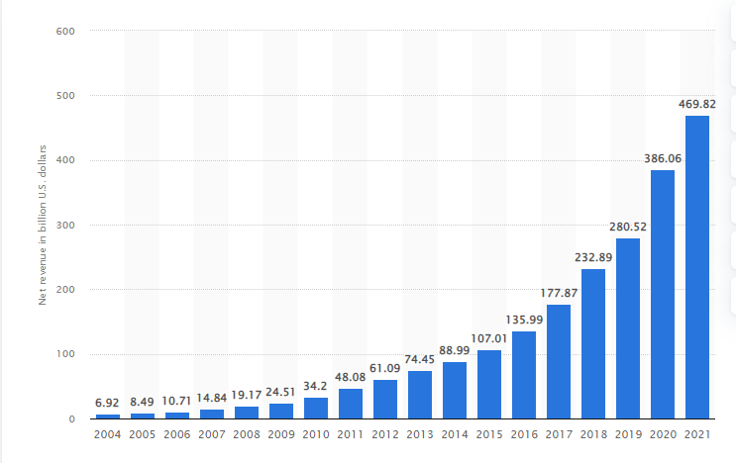

Figure 1 Net Sales Revenue of Amazon.com

Amazon.com, an American electronic commerce company originally founded in 1994, is the world’s largest online retailer of books, clothing, electronics, music and many more goods. As we can analyze from the above figure, from 2004 to 2010, the net revenue of the multinational company, Amazon.com was increasing at diminishing rate but after 2010, it gained its fame and increased its productivity and revenue at double rate.

As of 2017, the company generated the majority of it’s net revenues through online retail product sales, followed by third-party retail service , retail subscription like amazon Prime.

Through amazon, consumers are able to purchase goods at discounted price/ both new and used goods are sold on the website. Due to wide variety of goods available at different prices , Amazon has dominated the retailer market. In the recent years, , Amazon has also released smartphone, tablets and multimedia sticks under its Fire brand in order to increase digital media consumption via these devices. This strategy is connected to the digital Amazon ecosystem which features video and audio content as value-added services for Prime subscribers.

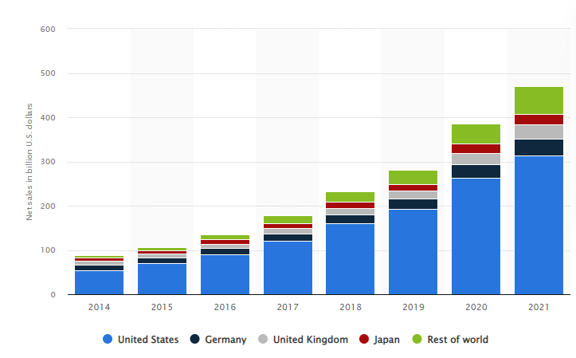

Figure 2Net Sales of Amazon.com in Leading countries

Above figure (Coppola, 2022) shows the revenue generation and sales of Amazon in different country. Amazon has separate website and market in different countries all over the world. From 2014 to 2021 years , we can conclude that, Highest sale of Amazon products and services is in the United States in comparison with Germany, United Kingdom, Japan, And rest of the world. In recent years, the sales is also increasing in other countries of the world.

# **2.TARGET CUSTOMERS**

E-business website like Amazon.com target each customers individually, allowing the corporate to convert visitors into long-term, high-value customers. Amazon target the central class & upper class people that have gotten hands-on experience with in the basic technology but don’t have time or prefer convenience over shopping from physical outlets. Amazon targeting a demographic that doesn’t have to struggle with a mortgage or household bills, and are among the most digitally savvy customers: American Teenagers.

The primary consumers or the target market of Amazon are the middle and upper-class people. Different genders belonging to these two categories equally contribute to the Amazon Target Market. These people use their smart devices or home computers to purchase products from Amazon. Most of them are aged between 18 and 44. Another interesting piece of data about the Amazon target market is more than 60% of primary consumers are from the United States. Amazon mainly directs its focus on the people who have access to the internet and frequently use it. (Who is the Target Market of Amazon, 2022)

Most people who buy from Amazon have basic knowledge about using smartphones. Additionally, they will know how to navigate the internet. Amazon has designed its online shopping portal which is apt for people who have a tight schedule in a day and don’t have enough time to purchase products by visiting a store in person. By this, we can assume that most Amazon shoppers are leading a busy lifestyle. These people want to spend most of their time on work or other activities rather than visiting a nearby retail store.

# **3.BUSINESS OBJECTIVES**

This company is the largest online retailer in the US, it’s a definite leader of web commerce trade category. The major focus of Amazon’s business strategy is ‘customers’ satisfaction. People may find and order virtually anything they search for. (Business Objective of Amazon, 2013)

The major business objectives are:

* Satisfaction of the existing customers and attract the new customers. The customers are divided into three groups: consumers, sellers and enterprises. The strategic advantage of the company for customer are: selection, price and convenience.
* The increasing of the market share and growth of the revenue by: improving and diversification of Amazon services; introducing other marketing and promotional services, such as online advertising, and cobranded credit card agreements; developing Amazon web Services (access to technology infrastructure that developers can use to enable virtually various type of business). Current sales of Amazon consist of 55.4%, that are made in the North America and 44.6% of sales is made by the international market.
* Amazon is to increase its current market share 1.1% on sales of food and beverages by 2018, so it reaches or even overtakes the current Walmart market share of 17.3%.
* Others business objectives of Amazon.com are:
* Introducing innovations and developing new acquisitions.
* Developing the international markets.
* Development of the relations with partnering companies.

# **4.PRODUCTS AND SERVICES**

Amazon.com provide large number of products and services at its website include several media( books, DVD’s, music CD’s, videotapes and software),baby product, electronics, beauty products, gourmet food,health and personal care item, industrial and scientific supplies, kitchen items, musical instruments, watches, jewelry e.t.c.

Amazon is now gearing up in India and other biggest countries to play a role in the grocery retail sector aimed at delivering customers needs.

Amazon has a number of products and services available, including following :

* Retail goods
* Amazon games
* Amazon Art
* Amazon video
* Amazon Drive
* Consumer electronics
* Amazon studios, inspire ,Books .
* Handmade by Amazons
* Amazon Dash
* Amazon Books
* Amazon home services
* Amazon web services
* New book content production
* Donations
* Amazon Tickets and many more.

# **5.FUNCTIONS AND OPERATIONS**

## **5.1 Process of Buying Goods and services on Amazon :**

For buying goods and services on amazon the following steps are followed:

* Visit the product detail page for an item we wish to buy.
* Tap Add to cart.
* When we have finish adding items to our cart, tap the shopping cart icon.
* If we need to edit the items in our cart, tap save for later or Delete next to the item in the cart.
* Tap proceed to checkout and follow the on-screen instructions.
* Review our order information and tap place our order to complete the purchase.

## **5.2 Process of selling Goods and services:**

## **Process before Register:**

* Decide what you want to sell
* Choosing a selling plan
* Register and start selling

## **Process after Register:**

* Listing the product
* listing the products already on Amazon.com
* Listing the new product on Amazon
* Selling the product
* Shipping the product to the buyer
* Get the payment from Amazon.com

# **6.COMPARISION WITH OTHER SIMILAR WEBSITES**

Amazon is a true market place websites where anyone can buy virtually sell anything. There is a listed price where buyers can purchase the product and read consumer reviews.

Generally, the items sold here are new in comparison. Online retailers are constantly faced with decisions that can impact their business. One of the major ones being where they should be selling. Here we have compared Amazon with five other similar ecommerce websites.

## **6.1 ebay**

Like Amazon, eBay is one of those sites where we find just about anything, we’re after. They have auction listing for individuals and stores where we can bid for products and, if we’re lucky, grab a massive bargain.

## **6.2 AliExpress**

Business turn to buy material and products in bulk direct from the manufacturer or supplier. In other words, if we’re a business, then this this is our business. If not, we can still find plenty to appease as a consumer.

## **6.3 Miniln TheBox**

MinilnTheBox is a global marketplace for a huge variety of gadgets, electronics, clothing, household goods and more.

## **6.4Newegg**

While Newegg specializes in electronics, computers, gadgets and office supplies, we’ll also finds other products such as jewelry, apparel, and costumes.

## **6.5Walmart**

Walmart is famous as a discount department store/grocery chain that offers low, low prices. Shop the immense inventory online and have it shipped to our door, or, pick it up at a nearby store.

# **7. LEARNING FROM THE CASESTUDY**

Amazon CEO jeff Bezos has spent nearly half of his life inventing and revolutionizing e-commerce, and now he is the wealthiest man alive. Jeffrey Preston Bezos is an American internet and aerospace entrepreneur, media proprieter, and investor. He is best known as the founder, chief executive officer, and president of Amazon. His philosophy, which helped him build the online retailer into a colossus with a current market cap of about $380 billion,can be gleaned from his letters toshareholders since Amazon went public in 1998.

Here are the top two lesson that I have learn during the casestudy on Amazon.com.

## **.** Obsess over customers, not competitors

Amazon makes the point that tech companies especially obsess over competitors: They wait and see what rivals introduce, then try to match and one-up it. By listing to customers instead, Amazon built its Amazon Web Services (AWS) business, which was designed to solve the problems with too- expensive in-house application hosting and open-source products that weren’t robust enough to easily support fast growing or already-large companies.

## Take risks for market leadership

It took Amazon three tries to get its business as a selling and fulfillment platform off the ground. First it tried Amazon Auctions, a more-or-less direct aping of the model that put eBay on the map. That morphed into zshops, and finally into Amazon Marktplace, which accounts for nearly half the units sold on Amazon.com.

# **8.PAYMENT MODES:**

Customers can purchase from Amazon with a credit card, checking account, and debit card featuring a credit card logo or an Amazon.com gift card code. Amazon.com accepts a variety of payment options, including credit and debit cards.

Furthermore, different payment modes accepted by amazon.com are as follows:

## **Credit Cards**

Amazon accepts Visa, MasterCard, American Express, Diners Club -- U.S. billing addresses only, and the Discover card. The online outlet also accepts JCB, NYCE, EuroCard and Visa, MasterCard debit cards as well as prepaid credit cards. If using a prepaid credit card, you cannot use the card to sign up for Amazon Prime membership.

## **Amazon Store Cards**

Amazon accepts its own credit card and line of credit as method of payment, including the Amazon.com Platinum Visa Card and the Amazon.com Corporate Credit Line for businesses using a purchase order.

## **Gift Cards**

Customers can also pay for purchases from Amazon using an Amazon.com gift card available in a variety of denominations directly from Amazon as well as any store or outlet that sells Amazon gift cards.

# **9.Screenshots**

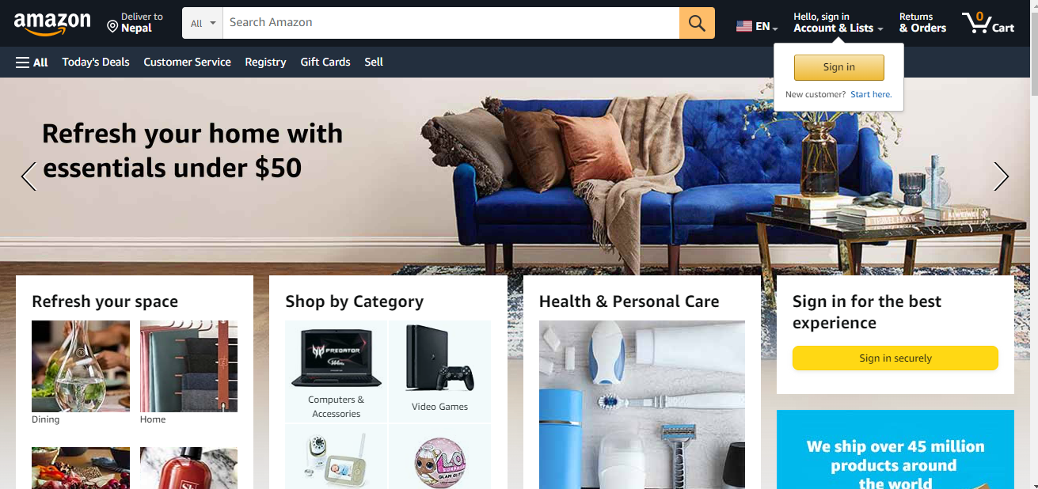

Figure 3 Home Page

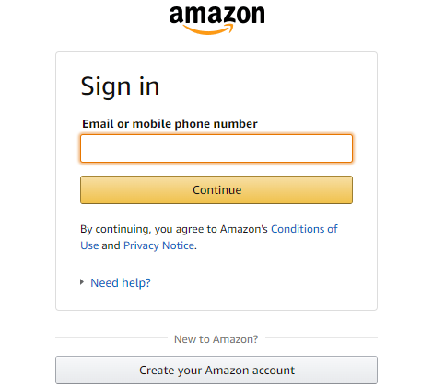

Figure 4 Sign In Page

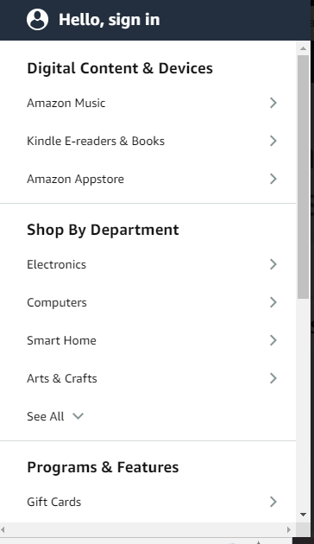

Figure 5 Category List

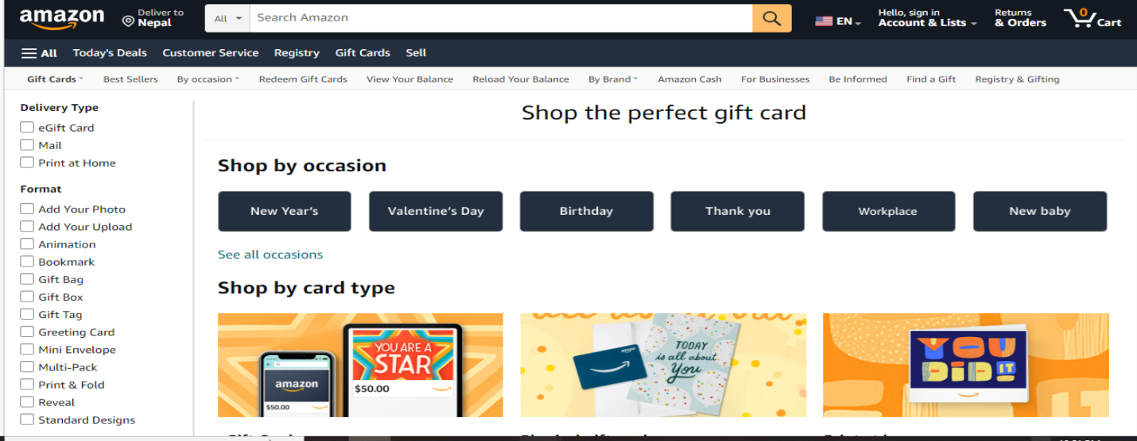

Figure 6 Amazon Gift cards

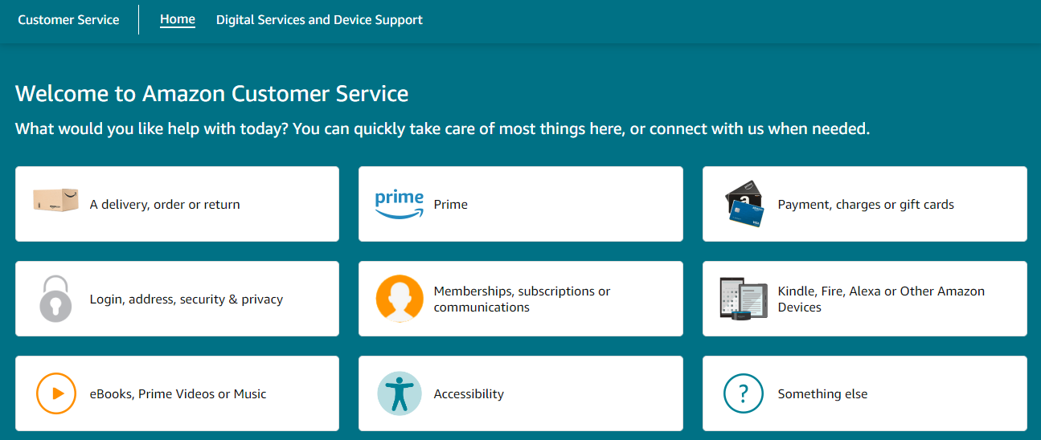m

Figure 7 Amazon Services

# **10.References**

*Annual Net Revenue of Amazom.com*. (2018). Retrieved from statista.com: https://www.statista.com/statistics/266282/annual-net-revenue-of-amazoncom/

*Business Objective of Amazon*. (2013). Retrieved from Custom-essay.com: http://www.custom-essay.com/custom-essays-on-business-objective-of-amazon/

Coppola, D. (2022, feb 14). *Net sales of Amazon in leading markets 2014-2021*. Retrieved from statista.com: https://www.statista.com/statistics/672782/net-sales-of-amazon-leading-markets/

*Who is the Target Market of Amazon*. (2022, aug 24). Retrieved from thesuperficial.com: https://www.thesuperficial.com/amazon-target-market-explained/#:~:text=The%20primary%20consumers%20or%20the%20target%20market%20of,of%20them%20are%20aged%20between%2018%20and%2044.